Port Logistics Plan – Port of Eastholm
Harrow Bay Offshore Wind
Elena Márquez · 02 September 2026 · HB-CON-PLN-0004

1. Port of Eastholm overview
The Port of Eastholm is the construction base for Harrow Bay and will become the operations and maintenance base from 2027. Weyland has leased Quays 2 and 3 with a combined laydown area of 14.6 ha and a quay length of 480 m, with a bearing capacity of 40 t/m² on the heavy-lift quay. Transit distance to the wind farm is 41 nautical miles.
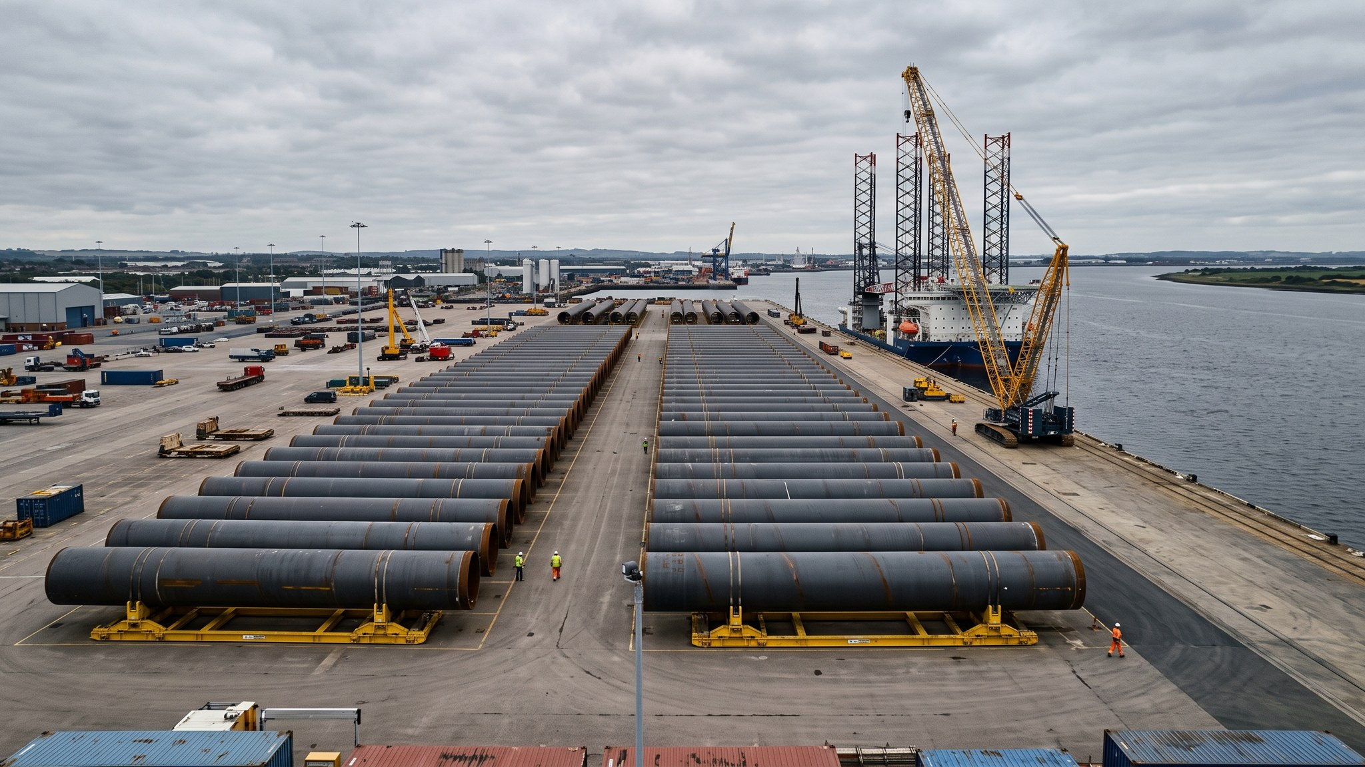
Monopiles of batch 4 on Quay 2, August 2026

2. Laydown areas
Area | Size | Use 2026 | Use 2027
Quay 2 – Area A | 4.2 ha | Monopile storage (max. 9 piles) | Blade storage
Quay 2 – Area B | 2.8 ha | Transition piece storage (max. 12 TPs) | Tower sections
Quay 3 – Area C | 5.1 ha | Cable carousel staging (from Dec 2026) | Turbine pre-assembly (Halden)
Quay 3 – Area D | 2.5 ha | Offices, workshops, warehouse | O&M base

3. Load-out sequence
MV Sea Atlas loads three monopiles and three transition pieces per trip (four monopiles from string B onwards, see decision D-016). Monopiles are skidded onto the vessel with SPMTs and sea-fastened; TPs are lifted with the vessel crane. A typical load-out takes 22–30 hours including sea-fastening and inspection.

4. Deliveries
- Monopiles and TPs by sea from Duisburg (Rhenus Steelworks), batch of six every 6–8 weeks
- Export cable 1 loaded directly at Severn's factory quay onto the cable lay vessel (no storage at Eastholm)
- HTS-12 nacelles, blades and towers from Aarhus from January 2027 – pre-assembly area agreed with Lars Henriksen on 21 May 2026

5. Port rules
- Port speed limit 5 kn, VHF 14 for port control
- Hi-vis, helmet and safety boots in all laydown areas
- SPMT moves only with a banksman and closed traffic lanes
- No lifting above Beaufort 6

